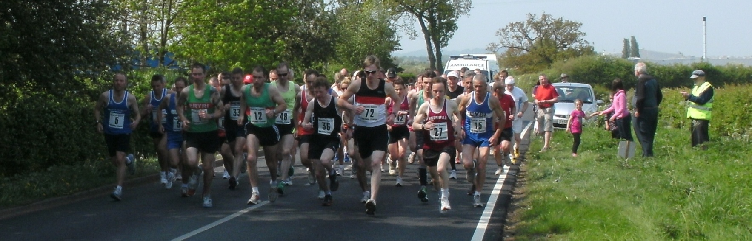

North Wales Closed

Senior Men
1. D. Damiani 2. B. Rothery 3. S. Sayer
4. D. Roberts 5. A. Bromley 6. J. Brown

Masters Men
M35 1. D. Damiani 2. J. Brown 3. N. Parry
M40 1. D. Roberts 2. G. Nicholls 3. R. Goodwin
M45 1. M. Robbins 2. D. Boothroyd 3. A. Gannon
M50 1. G. Jones 2. A. Lewis
M55 1. I. Rothery 2. C. Higgins 3. C. Baldwin
M60 1. G. Owens 2. M. Ollier
M65 1. J. Morris 2. M.H. Edwards 3. J.J. Thomas
M70 1. R. Harrison-Jones .

Senior Women
1. M. Kitching 2. I. Redfern 3. E. Collins

Masters Women
W35 1. I. Redfern 2. J. Haenden
W40 1. M. Kitching 2. F. Higgins 3.V. Ronald
W45 1. E. Collins 2. L. Peter 3. A. Thomas
W50 1. G. Davies
W75 1. S. Symonds

Teams

Men Masters Men
1.Wrexham AAC 66pts 1. Prestatyn RC 31pts
2. Astley & Tydesley RR 69pts 2. Astley & Tydesley RR 31pts
3. Buckley RC 78pts 3. Buckley RC 32pts
4. Prestatyn RC 105pts 4. Wrexham AAC 34pts

Our thanks to the officials and marshals who gave up their Saturday afternoon to ensure the race went on smoothly – we all realise that without their support the event
could not be held. Thanks also to the St Johns Cymru Wales volunteers for their presence.

Thank you again to Linda and her staff at the Club House for their warm welcome and allowing us to use their excellent facilities.

We are also very grateful to Russell Goodwin of Grand Prix Express for his generous sponsorship – the fact is that he completed the race confirms his continued genuine interest in all our activities.

And, finally, my sincere thanks to all the athletes for taking part in this year’s Grand Prix Express North Wales 10 mile Championships. We are all very pleased with your support and hope you & your friends can come again for the 50th running of the event on April 28th 2012.

David Alun Williams
Hon. Secretary. North Wales Cross Country Association

Excel version of results; for word copy of results see next page

