SPOTLIGHT WITH ALI LAVENDER-ROWLINSON, OSWESTRY OLYMPIANS
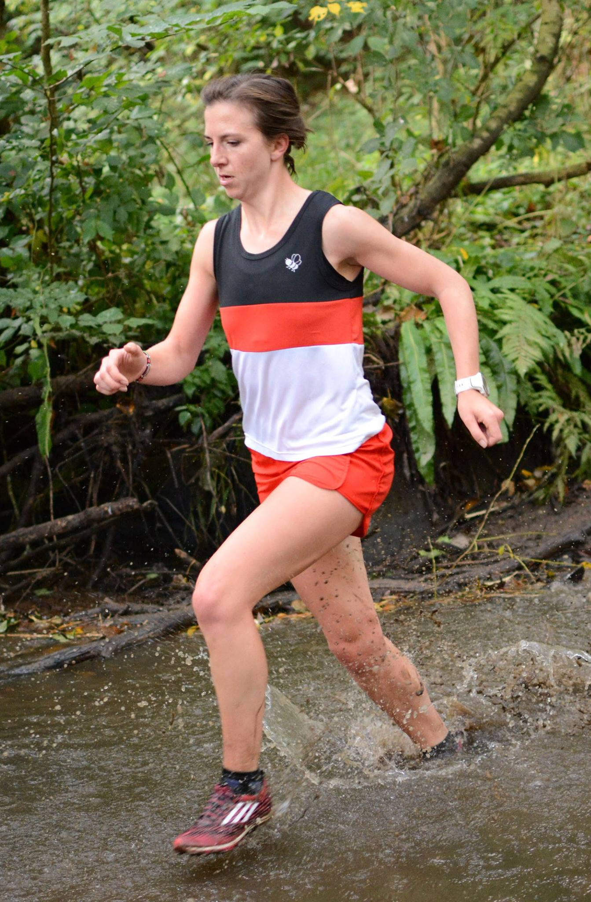
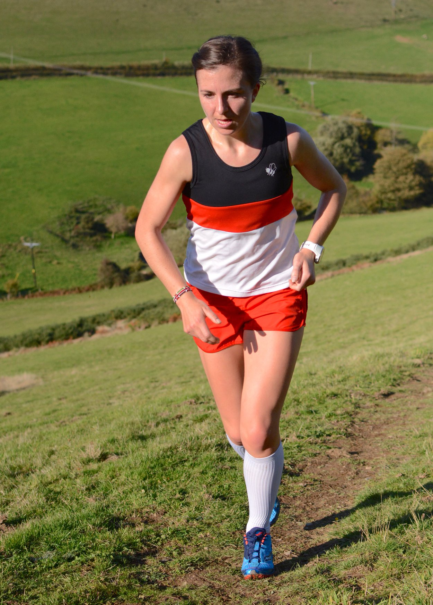
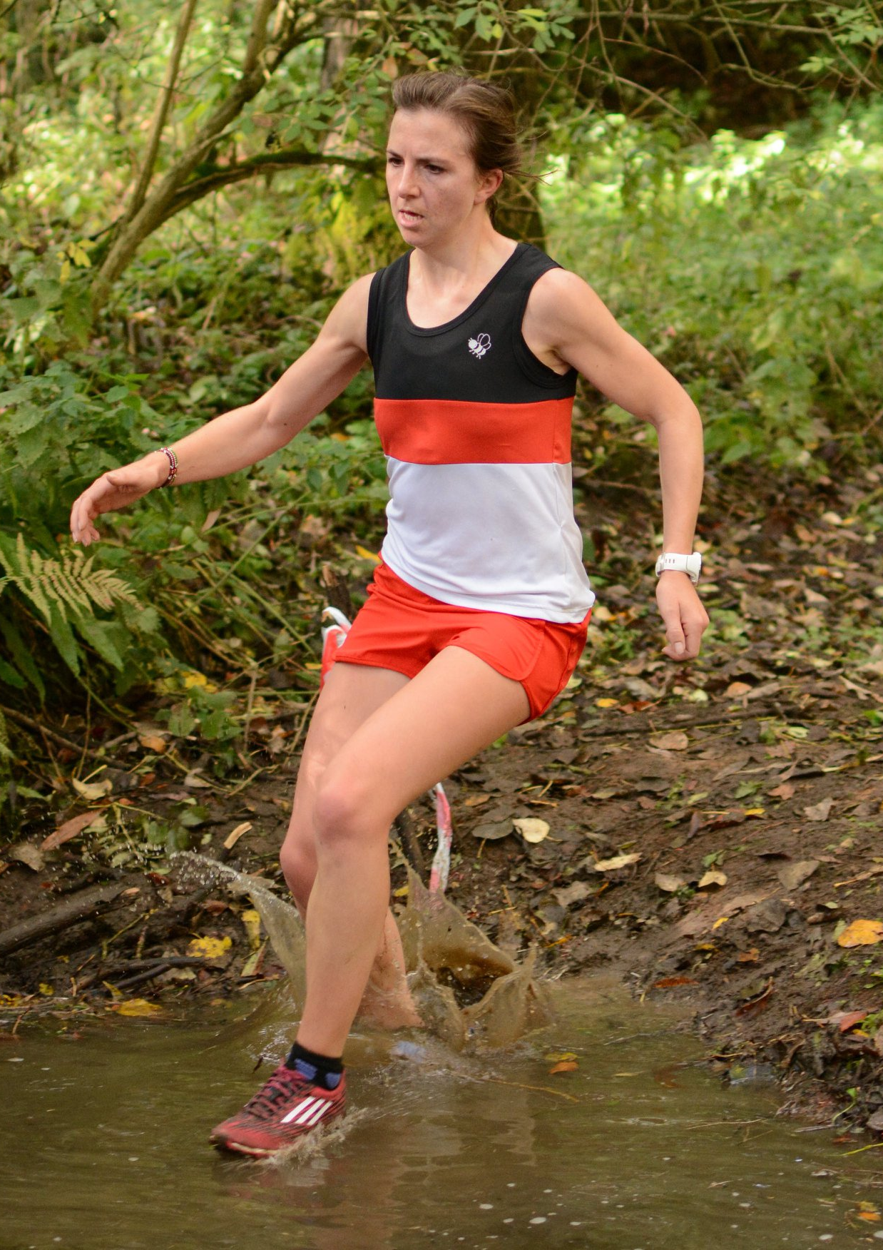

(Photos courtesy of Neale Jones, Eryri Harriers)

Ali Lavender-Rowlinson, Oswestry Olympians is the second most prolific race winner in the history of the league and despite competing for England and Great Britain she has remained loyal to Oswestry Olympians and a regular competitor in the North Wales Cross Country League. Here she answers a few questions:

1: How and when did you start running?
I started running when I was pretty small when my sister was already a good runner. A teacher at our primary school (Pontesbury), Keith Matthews, wanted me to join in with their training so potentially I was around 5.

I was involved in the schools cross-country races plus the Pontesbury Hill race plus the Shropshire Young Athletes League. I think the hills around where I grew up made me tough and chasing a few animals on the farm probably helped!
I initially joined Shrewsbury AC and transferred to Oswestry when I was 14.

2: My records show that you are the second most prolific race winner in the history of the North Wales Cross county league with 23 wins (Claire Martin has 40!) and you won your first race at Treborth, Bangor in November 2009. However before that you also won the Under 17 women overall title in 2005/6. What recollections do you have of your early races in the league and your first win?
I remember being asked to go along to the league races and getting a lift with some other Olympians to Bangor – which seemed very far away! From memory, I initially finished around the top 10 before a lot of third places because of runners such as Claire and Marilyn Kitching. Finishing second to Anna Frost at Bangor is one clear memory when I was very happy with my finish.

Starting to win some of the races was a great confidence boost and I have always loved competing in the league.

The Shropshire Schools Championship has clashed with the final race of the series over the years and I once raced the schools event in Telford before rushing over to Oswestry to finish the series.

3: Do you think Claire Martin’s record will ever be beaten?
Claire is still running amazingly well in the vet categories and that shows I still have some years of running ahead of me to catch her up. There will no doubt be some youngsters who come through and will be able to challenge those figures in the future – I’ve just got to hold them off for a while yet!

4:What are your PB’s?
3km - 9:31
5km -Track 16:32, Road 16:55 (ran 16:20 on Christleton when it was marginally short!)
10km - 34:04 (Speedway 2020)
10mile - 56:00 (2019)
Half - 76:43 (Granollers 2020)
Marathon - 2:41:18 (Berlin 2019)
5: You’ve competed for England; finished 4th in the Midland Cross Country Championships and 11th in the National but what performances have given you the greatest satisfaction?
Finishing so high in the English National was fantastic – and I would have finished higher if I had not set off so fast (sorry Andy!). My 15th place finish the previous year had showed me I was ready to move up another level.

Getting England vests over many disciplines (mountain, cross country and road) is always a privilege and getting another one this year after 5 years of hard work to get back to a higher level meant a lot. I got my first vest at English Schools cross-country in 2003 and am proud to still be going 17 years later when a lot of people have dropped out along the way.
In 2014 I ran for England over cross-country on a Saturday, finishing 5th, then ran a 76:44 PB at Wilmslow Half on the Sunday so that was a fantastic weekend!

Being the first GB female at Berlin Marathon in 2019 and getting onto the all-time rankings for the marathon was very special.

6: And the greatest disappointment?
Losing time to illness/injury is always frustrating so having around 3 years of underperforming was tough.
There are always disappointing races but the good outweighs the bad overall and you learn from it hopefully!

7: What is a typical week's training?
Training will depend on what the race focus is at the time. Normally we have two sessions per week, Sunday long run, one rest day and some easy running on the other days. Around this there is gym and core work. During marathon training the mileage would be higher with some longer efforts and finishing Sunday runs with marathon paced effort.

8: You had some serious injuries and took a long time to get back to full fitness. Tell us about the injuries and the battle to get fit again. Did you ever consider giving up?
I had a few years of recurring illness which was then followed by injuries too, which made it a lengthy time of disruption. Illnesses included pneumonia and kidney infection as well as some time struggling to train with unidentified problems. Following this I had stress response in my tibia which put running completely on hold.

It took a long time to get back to full training and I would say I have only recently got back the level I should be performing at.
Having time out and struggling to rebuild is tough mentally as well as physically and having confidence you will get back can be difficult when you struggle to run at a pace that used to be easy.

The great support team I have around me was key to getting back with people to coax or kick you out the door and make you believe it is all worthwhile. Learning how to look after yourself better, whether that be supplements, recovery or running easier is necessary to longevity and consistency.

9: You’ve been coaches/advised by North Wales legendary coach Andy Walling for a long time. Tell us about how that works?
Andy has been coaching me since 2013 and has done so both remotely and in person when we were both based in North Wales. Building a relationship and knowing his athletes is a great skill that Andy has, taking into account other factors in life and how they affect running. Andy’s been a key figure in my life, listens and empathises but gives you a straight answer when necessary. The words ‘You’re better than that Ali’ are the ones that permanently stuck in my head following me taking part in a race I shouldn’t have rather than seeing the bigger picture. The training week is sent over on a Sunday evening and we feed back to him during the week, adapting if needed. The training has evolved over that time, as we have learnt what works for me and as Andy is forever learning new things to add into the mix.

10: Comments on:
- Running in North Wales/Shropshire
The running scene in the area is one of the most inclusive I have experienced with a vast mixing pot of people competing for GB/Wales/England down to age groupers who have a much larger running CV than us! Some of my closest lifelong friends have been made within this area of running.

- Oswestry Olympians
The Olympians are such a friendly and enthusiastic club which make me feel very valued and welcome, even though I can’t get involved with everything because of living further afield and prioritizing other events to aid my progress. I joined when I was around 14 after starting training at the old Park Hall track with John Roberts who was coaching Ollie Blake at the time. Other clubs have unsuccessfully tried to poach me but I love the black, red and white too much!

A big thank you to Ali Lavender-Rowlinson. It’s great to see such loyalty to her club. Good luck for the future.

