SPOTLIGHT WITH ROGER HARRISON-JONES, PRESTATYN RUNNING CLUB

The North Wales Cross Country League is the oldest cross country league in Wales and started in 1958. Roger Harrison-Jones, then of Rhyl AC and now of Prestatyn Running Club, not only took part in that first race but won it. More than 60 years later Roger is still running and racing and even managed to win his last race, the BMAF Cross Country Championship, the day before lockdown!! Here Roger answers a few questions and gives an insight.

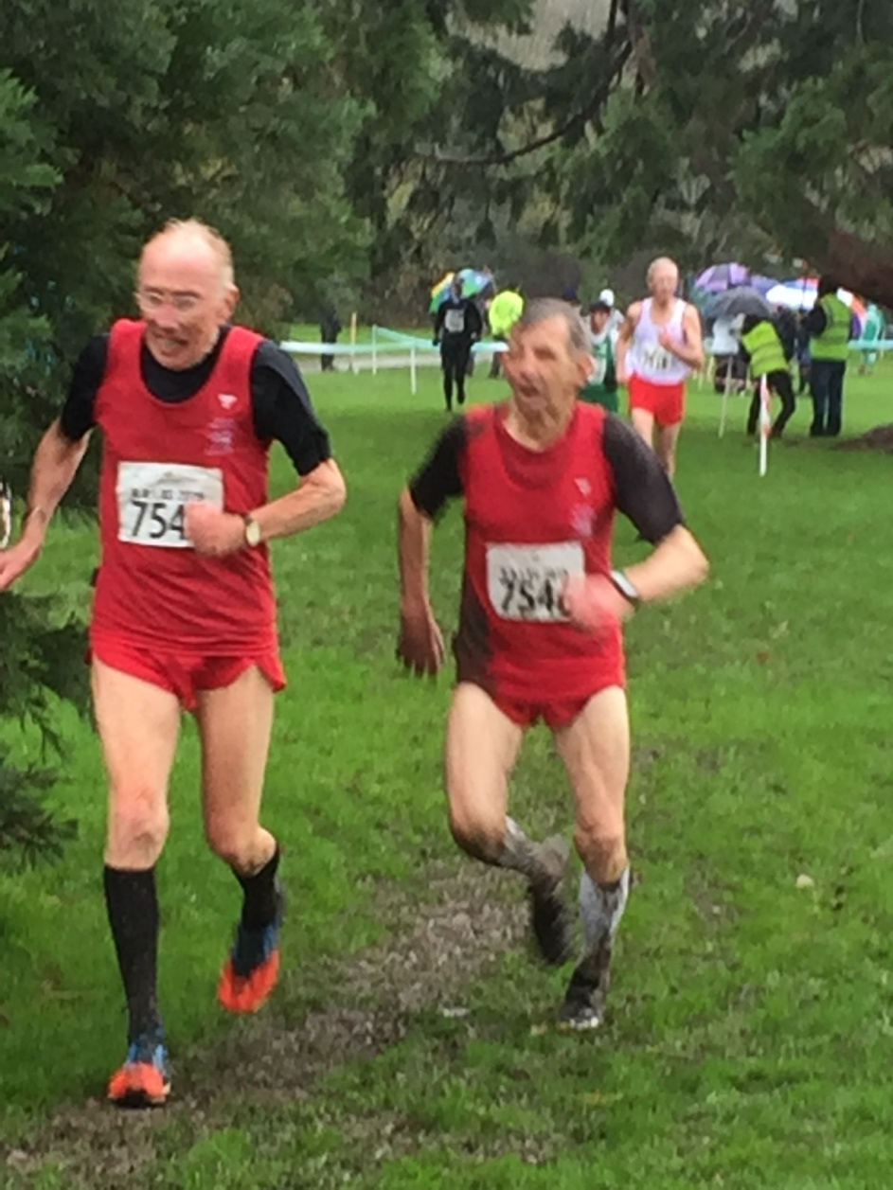
Roger Harrison-Jones, running for Wales in the BMAF International Cross Country
Alongside him is long-term club-mate and competitor, David Hughes, also of Prestatyn RC

- How and when did you start running?
I probably had three running careers, approximately 20 years apart.

I started running in 1953, and have been a member of Rhyl AC, Wrexham AC, Liverpool Pembroke, together with Hayes and Harlington whilst doing National Service. Prestatyn RC came much later.

Whilst running for Liverpool Pembroke, Ray Billington, David Hughes and myself became friendly with fellow runner Alan Caldwell. His stage name was Rory Storm and the Hurricanes. At the time they were bigger than the Beatles and Ringo Starr was his drummer.

I was persuaded at the age of 43/44 years old to enter the first London Marathon in 1981. I eventually did four London Marathons, but ten marathons in total. Roger’s best marathon time was 2 hours 49 mins and 4 seconds but one that he was not satisfied with as friends had times under 2-35.

My third running career started in my late 60’s since when I have won numerous North Wales, Welsh and British individual and team medals with Prestatyn Running Club.

- Not many of the current crop of athletes would realise that not only did you take part in the first ever North Wales Cross Country League at RAF Valley, Anglesey on 18th October 1958, but you won it. I know it’s over 60 years ago, but do you have any recollections of the race?

I don’t have too much recollection of the first race but do know I made a big mistake in 1958 at the Welsh Cross Country Championships. I knew John Disley (Olympic Steeplechaser) as we used to train together at Eirias Park in Colwyn Bay. During the race he was struggling and in real trouble. I slowed down to help and encourage him. He recovered, finished one place in front of me. He was selected for the Welsh Cross Country Team and I wasn’t. (John Merriman, Watford won the 1958 Welsh Championships. Roger did finish 2nd in the Welsh Cross Country Championships in 1961 and third the following year).

- In your younger days you competed for Wales in the International Championships (the equivalent and forerunner to the World Cross Country Championships). Do you have any memories of those days?

Between 1959 and 1964 I was selected to run for the Welsh Cross Country team five times. They made me Captain in 1964 but the only duty I had was to ask the team members what they wanted for breakfast.

My first flight and first vest was in Estoril, near Lisbon, Portugal. I went back there in 2017 to reminisce. The cross country races were much longer in those days, mostly 8 or 9 miles. The Nantes race in France in 1961 was memorable as they had medium sized hedges to race over. On one uphill section they had this hedge with a ditch on the other side!! (can you imagine the risk assessment for that these days….or some of today’s athletes contemplating running such a course!!).

(Roger’s results in the International Cross Country Championships were as follows:

1959 - Lisbon, Portugal - 64th
1960 - Hamilton, Scotland - 67th
1961 - Nantes, France - 70th
1962 - Sheffield, England - 77th
1964 - Dublin, Ireland - 71st

- What were your pb’s

In the 50’s and 60’s there were many more track races than they have today. Albeit, it was of course on a cinder track. The spikes didn’t have any cushioning either! My track pb’s were:

Half Mile: - 1 min 57 secs
Mile: - 4 mins 16 secs
Two Miles: - 9 mins 0 secs
Three Miles: - 14 mins 2 secs

(Roger finished 3rd in the three miles in the Welsh Championships in 1957 and 3rd in the mile in 1959)

In 1964 I ran the Port Sunlight 15 miles road race in 85 mins 17 secs.

- What performance(s) have given you the greatest satisfaction?

One is only as good as one last race. So whilst at this difficult time during “lock-down” I can only think of the British Masters Cross Country Championships at Rhug in March organised and officiated by Bernie Jones and Gareth Hughes. I won the M80 category by one second. The memories of that race have kept me motivated in these difficult times (I watched Roger and David Tomlinson, Bolton sprint finish in my privileged position as Race Referee hoping that Roger managed to stay ahead and I did not have to adjudicate against him. Fortunately despite being 83 years young, he still had a change of pace to manage a one second victory over David Tomlinson).

Another good day out was in September 2018 at the World Masters Championships in Malaga, Spain. Although I was 81, I was asked to run for the Great Britain Masters M75 Half Marathon Team. On a hot humid day we won Team Silver, second to the German team. It doesn’t get much better than that!! My other name isn’t Angela Copson (5 gold medals).

- What was a typical weeks training back in the 1960’s?

I still have my training diaries from 1956 to 1959 so I know exactly what we used to do. It was 30 to 40 miles per week. A lot of Fartlek and also a lot of fast interval work on the track. I can see in my diary that the distances we did varied, but below is a sample session:

8 x 440 yards @ 62 secs pace with 440 yards jog recovery
8 x 220 yards @ 28 secs pace with 220 yards jog recovery

- What is a typical weeks training now?

Masters training is 15 to 20 miles per week all on grass, usually about 5 runs per week. One day would be 1 hour Fartlek incorporating plenty of hills. Another day would be 100 yards straight sprints (fast strides) x 40 with a few seconds rest in between.

- Masters Running

I LOVE IT.

I was very slow in getting into Masters events. I have won BMAF titles in my age category, together with the honour of running for Wales in the BMAF Cross Country International. When not selected I have become an enthusiastic supporter (as Welsh Team Manager I can confirm that Roger is the first to contact me about the Cross Country International, confirm he will be attending regardless of whether he is in the team or not. He loves the camaraderie of being part of the Welsh team and it clearly means as much to him now as it did 60 years ago!).

Roger’s pb’s as an M70/M80 are as follows:

M70 10km - 47 mins 17 secs M80 10km - 55 mins 30 secs
5km - 23 mins 02 secs 5km - 26 mins 57 secs

- Any other comments

I am not one for name dropping! At least not all the time. Whilst I was doing National Service, I spent some of my time in RAF Compton Bassett in Wiltshire whilst only down the road in RAF Yatesbury was Dereck Ibbotson. Very, very nice bloke. I had to race against him most Wednesdays, whilst on Sunday he would wander off to the White City track in London to break the World record for the mile in 3 minutes 57.2 seconds.

I am reminded of a true story which at the moment is very topical. In 1964 I won the Liverpool Pembroke Club Cross Country Championship. My wife Valerie and myself travelled to a hotel for the presentations. The Mayor was giving out the medals etc. In his speech he explained he wasn’t an athlete and had never belonged to a running club. “I tell a lie” he said. “During the second World War I belonged to Dunkirk Harriers, I have never run so f*****g fast in all my life”.

A big thank you to Roger Harrison-Jones for doing this Spotlight. His longevity is incredible and he is one of the nicest gentlemen around and despite his advancing years is always prepared to get stuck in and give a hand. We salute you Roger Harrison-Jones

