**SPOTLIGHT WITH TONY BLACKWELL, WREXHAM AC/WOLVERHAMPTON & BILSTON**

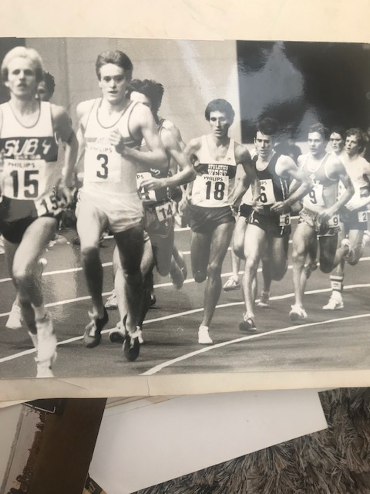



***Tony Blackwell is the second most prolific winner of the North Wales Cross Country Championships with five victories in the late 1970’s/early 1980’s. Despite joining Wolverhampton and Bilston at a young age, and therefore being unable to run in the North Wales League, Tony is also one of the most successful athletes in the North Wales League, winning his first race at Shrewsbury in March 1977. Tony is also the most successful winner of the Chester Round the Walls Race with 4 wins and a number of other podium finishes.***

**1: How and when did you start running?**

My early inspiration came from watching my uncle Viv (Blackwell) when on leave from the RAF, Viv represented Wales on a number of occasions at both Cross Country and mainly track and he also competed for Wrexham. I would watch him train whilst on leave and would think I was a runner whilst running around streets at home. I started competing whilst in High school and I was inspired further when Viv and I went to the 1972 Munich Olympics.

Viv went on to coach me for the remainder of my time in Athletic.

**2: My records show you won your first North Wales Cross Country League at Shrewsbury in March 1977. Do you have any recollections of your first win?**

I don’t have any recollection of my 1st or last wins in the NWXC league, but I always remember having to arrange a lift on a Friday night with Les Baldwin and always getting stick off David Alun Williams (***didn’t we all!!)***.

I always remember the RAF Valley course being 6 miles of Hell on earth – wind, rain and sand underfoot.

**3: My records also show that your last League race win was at Much Wenlock in November 1988. Any recollections of this?**

According to the Wrexham Harrier Magazine, which was a news letter type of monthly mag written by one of the Wrexham team; I ran out the winner on a hilly course and turned the tables on Emlyn Roberts of Eryri who had beaten me in the previous race at Bangor.

**4: You are the third most successful men’s race winner in the League despite spending many years unable to run in the League during your peak due to moving clubs from Wrexham to Wolverhampton and Bilston. What are your recollections of the League?**

I would have been happy to have continued to compete and support the NWXC league during my years at Wolves, but the rules wouldn’t allow 2nd claim runners to compete, I did complete for a short while as 2nd claim in the North Staffs until the rules were changed. The original reason to move clubs was to further my track carrier and having to serve a 9 month ban was unfair and I always felt that the rule would deter many athletes.

**5: You are the second most prolific North Wales Cross Country Championship Senior Men winner. What memories do you have of your five wins?**

Always remember having trouble deciding which race to choose from Youths, Juniors and Senior races, my 1st senior win was whilst still being able to run in the Junior race. Always remember the Denbigh High School course and its infamous swing gates.

**6: What were your pb’s?**

***Track***

400m hurdles – 56 secs

800m - 1:50

1500m - 3:40:53

1 mile - 4:00:52

2000m – 5:07:45

3000m – 7:56:83

3000 Steeple Chase – 8:40:58

5000m – 13:53

***Road***

*5 miles - 22:50*

*10k - 29:31 (ran faster at Twin Piers with the wind not sure of the time)*

*10miles – 48:22*

*Half Marathon - 66:46*

*20 miles Rhayader lakes - 1hr 45mins (pre London 1988)*

*Marathon - 2hrs 21:56 London 1988 (one and only marathon)*

**7: You had some terrific achievements during your running career. Which were the most pleasing?**

*Gained various honors during career.*

Welsh Track Championship wins 1500m 1981 & 1983; - 5000m win 1984

3000m Youth and Junior Championship win 1975 &1977

Welsh Cross Country Championships Junior 1st 1978; and Senior 2nd place 1981 & 1983( beaten by Steve Jones).

Represented Wales at the World cross country champs 4 times 1981, 82, 83 and 84.

With some pleasing results at British National level.

2nd UK Champs 1984 - 3000m S/C (selected to represent Great Britain)

7th English AAA 1500m Champs

3rd Team at 12 stage relays and 3rd Team at the English National Cross country with Wolves

4th English AAA 3000m and 7thEnglish National cross country Junior championships

5thYouth Inter counties cross country

2nd English AAA 1500m S/C and 4th British Schools 3000m

One found Memory was when Wrexham won the Burtonwood relays Warrington (this was a big event at the time) at Youth age group with Bernie Jones, Ian Williams, Vaughan Edwards beating the current English Champs Gateshead AC.

**8: And most disappointing?**

This is an easy answer – Not being selected by the Welsh Athletics for the 1982 Commonwealth games Brisbane when I had been told I was a certain selection only for Malcom Arnold to overrule the selection. Also having a motor bike accident 2 weeks prior to the 1984 Olympic trails 3000s/c after finishing 2nd in the UK champs. Also missing out on GB vest due to accident.

**9: What was a typical week's training at your peak?**

The year was generally broken up as follows

Sept – Nov was a recovery period following the Track season running around 70 miles per week.

Dec – March Increase mileage and intensity to 100 miles per week – 13 runs and sessions with 2 weight sessions.

March - May The mileage started to drop when adding Hill sessions and increased the interval sessions

May – Sept 60/70 miles per week

The following training was taken from a week in my old dairy form when I was 18 and had the success at National Junior level;

Sun – 2hrs 20mins easy Long run

Mon – am: 5miles easy – pm: 20 x 60secs fast 2mins recovery 10 x 60secs fast (off 60 secs rest between efforts)

Tues – am: 4 miles easy – pm: 8 miles easy

Weds – am: 6 miles easy – pm: 10 x30secs (off 30secs) 2mins rec 4x100secs (off 100secs ) 2mins rec 4x3mins (off 3mins)

Thurs – am: 6 miles easy – pm: 2x1mile 4mins 40secs 10mins recovery 4x800m 2mins 15secs 5 mins rec 8x400m 65-70secs

Fri – 8 miles easy

Sat – Race or session on grass

Highest mileage recorded was 156miles – went a bit to far and got injured. No wonder

**10: You retired from running due to injury. Can you outline what happened?**

In 1984had the motor bike accident whilst travelling as a pillion returning from work one evening. Broke my left leg in 3 places, this meant I had a couple of years off and getting strength back in legs. Returned for a period of 3 years from 1986 to 1989 moving from Wolves back to Wrexham ac. The pain become to much when trying to get back to the amount of training required to run at the previous levels.

**11: Despite not being able to run you have kept yourself fit over the years. How have you been able to fulfill your competitive nature?**

Following a few years spending time with the children, I took up cycling, mainly mountain biking at the time and competed at Nation league level, ranking 2nd in age group at National level and taking a Welsh age group title. Over the years my left leg and knee has deteriorated which has lead to having it rebroke and pinned earlier this spring, the road to recovery started again.

**12: Comments on:**

1. **running in North Wales–**

**I** would have continued competing in NWXC league if allowed as 2nd claim and always tried to compete in the North Wales championships. In 1978 whist still a Junior I won my 1st Senior of 5 NWXC titles.

1. **running for Wolverhampton and Bilston –**

I feel the decision was correct compete for a club outside North Wales as it furthered my track career, competing in the European clubs cups a number of times and competing in the British Athletics league and having to double up running 5000m and 3000s/c with 45mins between races. Following my time at Wolves I was made a lifetime member.

***In my humble opinion Tony was one of the most talented and hard working runners to come out of North Wales and was very unfortunate to miss out on Commonwealth Olympic Games, initially due to selection disagreements and subsequently his motor bike incident. Who knows what Tony would have achieved without the accident? We will never know but his record still speaks for itself.***