SPOTLIGHT WITH ALI WHITELAW, WREXHAM AC

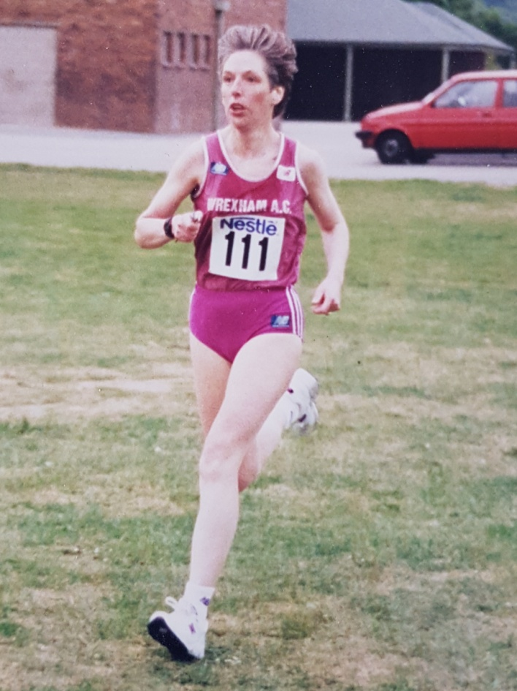

Ali Whitelaw, Wrexham AC has been one of the leading runners in North Wales over the past 35 years finishing in the top 3 places in the North Wales Cross Country Championships on 10 occasions and picking up 12 age group titles. She has also won many Welsh and British Masters titles and for the past 15 years has combined running with Team Managing the Welsh Women’s Masters Team.

1: How and when did you start running?
In 1985 I’d started to go out with Andy Whitelaw again (having first met him in 1978). He was a keen runner now and had joined Wrexham AAC. I wanted to lose weight, [I was 11 stone] and thought why not have a go. Andy was very encouraging and helped me with my training schedule. I was aiming to do the Shrewsbury half marathon but managed to fall off my bike and break my collarbone so running came to an abrupt halt. I got back into training and my first race was the Shrewsbury Boxing Day 5mile in 1986. I was so nervous as I didn’t want to be last so Andy ‘ran’ with me and he made sure I wasn’t last, he finished last and I was second to last. I completed my first 5 mile race in 48.01.

2: Despite starting later, my records show that you are one of the most prolific race winners in the history of the North Wales Cross county league with eleven wins and lots of top three finishes. You won your first race at Madeley Court, Shrewsbury in February 1990. What recollections of that do you have?
I remember it well (it was actually Madeley Court, Telford). I was really enjoying my running as all my training had started to show results and in cross country I was getting closer to finishing first so it was my ambition to achieve this. It’s strange how running makes you so competitive as I had never been interested in doing well in sports, content just being able to compete. On that day I remember going on the club bus and listening to David Williams’ usual banter. Tracy Clarke from Telford AAC was the girl to catch as she had been winning the previous races and I remember catching her, passing her and then running as fast I could to the finishing funnel hoping she wouldn’t catch me. I was so pleased to be handed that No 1 ticket and I know there was another runner who was equally pleased as me, Andy.

3: Despite winning 12 Masters Titles and having 10 top 3 finishes in senior women race at North Wales Cross Country Championships you never actually won the title. Was this frustrating and how close did you get?
I am frustrated not to have won a North Wales XC Championship. I was second so many times, to different winners. One year I managed to pass Lynn Madison (Col Bay) but then Liz Hughes (Aberystwyth) passed me to win, another time I passed Liz Hughes and Lynn Madison won, and so on, and so on. The one time I thought I would win was when I’d won all the North Wales League XC races in 1998 so was running well but the day before I went down with a heavy cold and on the day of the race, I felt rotten but decided to do the race anyway. The race was being at Welshpool on fields by the Leisure Centre. I was leading the race and really thought this was going to be my day despite my cold, I was sprinting to the finishing funnel when this girl who I’d never seen before sprinted in front of me and got there before me. I was gutted and so disgusted; I went home without stopping for the presentation.

4: What are your PB’s?
Track Road
800m: 2.25 5K: 17.06
1500m: 4.48 10k: 36.22
1 mile: 5.21 10 mile: 59.09
3,000m: 10.00.05 Half Marathon: 1.21.44
5,000m: 18.12 20 mile: 2.28.48
10,000m: 36.56 Marathon: 3.23.58

5: You competed for Wales on many occasions both as a senior and master but what performances have given you the greatest satisfaction?
- Winning the 3,000m Welsh Track Championships in 1990 which resulted in getting selected for Wales to run in the 3,000m at the Welsh Games which were held in Wrexham later that year.
- In 1994, winning the Chester Half Marathon, having to ask if I could have my prize money asap as I was competing in the 3,000m on the track at Colwyn Bay in a GRE Cup that afternoon and winning the track race.
- Managing to win all the North Wales League Cross Country races in 1998. The following year I came second in all the races, each to a different winner.
- Running for Wrexham AAC in the Welsh Castles Road Relay 1998 on the Saturday winning the 2nd Stage and then running for Air Products PLC on Sunday winning the 13th Stage (at the start of the race I heard some South Walian girls say she’ll be tired, she ran the day before so she won’t do well today!)

Looking through my diaries 2005 was a good year for memorable performances and all were as part of a team:
- 12 March: British Masters XC Championships at Bangor, Northern Ireland. Myself, Margaret Docking and Ros Adams representing Wrexham AAC got the first team prize and I got an individual silver medal. The course was great, the weekend was great and what made it even better was that the Wrexham Mens team were there and they won third team prize.
- 21 May: Sutton Park National Masters Relay Championships. Myself, Ros Adams and Alexi Hamilton-Jones representing Wrexham AAC won the gold medal.
- 12 November: British & Irish Masters International Cross Country in Santry Park, Dublin. I was part of the Welsh W45 Team (Cath Wheeler, Ann Evans and Ann Nixon) and we won team gold. We had all had a great race with Cath finishing first and then myself, Ann Evans and Ann Nixon finishing all together.

6: And the greatest Disappointment?
You may have gathered, not winning the North Wales Cross Country Championship. I was also disappointed in 1991, when I had been running so well and had got selected to run for the Welsh Senior Team in a cross country race being held in Margate but had to withdraw due to a stress fracture of my shin and I was unable to run for 6 months.

7: What was a typical week's training at your peak?
Monday: 6 miles in morning before work and 4 miles in evening
Tuesday: 4 miles in morning before work and track speed session in evening (i.e. 12 x 300 or 6 x 600 with 90secs rest)
Wednesday: 13 miles in evening
Thursday: 6 miles before work and track session in evening (16x400m with 30s rest)
Friday: Rest
Saturday: 6 miles or road/cross country race
Sunday: 18 miles or road/track race

8: You started later than many and had great deal of success as a master athlete. Did your training change much as you got older?
When I was training hard, I would train twice a day with loads of track sessions and did a lot of track and road races. I even managed to do a cross country race on the Saturday and then do a Border League race on the Sunday (managing to win both!). However, injuries started to creep in: achilles, plantar fasciitis and now patellofemoral arthritis of both knees which has curtailed my training somewhat and so I had no choice but to cut back on the training. I did concentrate on quality work not quantity, so still did two speed work sessions and reduced my mileage to 25 to 30 miles a week.

9: You have been Welsh Masters Women’s Team Manager for over 15 years. Tell us about your experiences and why you do it?
I cannot believe that I’ve been Welsh Master Women’s Team Manager for 15 years, time has gone so quick! First of all I have to say that without Bernie Jones’ organisational skills, knowledge and humour; I would not want to be Team Manager. It is without doubt he has helped me no end in doing my job. Selecting the teams is no easy task and Bernie’s support is really appreciated. I always enjoy the International weekends; it’s so good to meet up with the runners and although you might not have seen them since last year’s race, there is always a good camaraderie. You are also meeting new members as they’ve either moved up to the Masters ranks or their running performances have earned them a place on the team. The level of competition is of a very high standard and the races are great to watch. The last few years I have just managed the team but when I became team manager I used to run in the team as well which could be quite a challenge. There have been some great venues for the cross country races and sometimes the organisation has not always gone to plan, for example the time when the International in 2009 was being hosted by England. The race was being held on the grounds by Alexandra Stadium. England had organised the team hotels in Solihull so buses were organized to transport the runners to the course on the Saturday morning. I waited with our team for the bus to come but it didn’t turn up, apparently the driver had picked up runners from the England hotel and driven straight to the course. Luckily some of us had driven to the hotel so it was pack a car time and dash up the M6 to the course. I had with me the numbers for the runners who were coming straight to the course so by the time I arrived, it was a manic half hour of making sure everyone had got their numbers (and it was windy and pouring down with rain at the time). I was also running in the race so had no time to warm up, mind you I was so stressed by then I think I ran the race on adrenalin and surprisingly had a good run. I have been left though with this fear of buses not turning up!

10: Although you’ve been injured for the past couple of years, prior to that you’d competed at a high level for about 30yrs.What do you put your running longevity down to? Any advice for other athletes?
I enjoyed training and seeing the results of my training come to fruition in the races. I always thought what was the point of training if you didn’t do a race although nowadays for me, I’m just ticking along enjoying my running at a very slow pace. Andy’s advice to me was training was like putting miles in the bank, you don’t need to run fast all the time as you are then just making yourself tired and putting pressure on yourself. Run slowly in your training runs and only run fast if you are doing a speed session or a race. I never ran if it was icy/foggy/very windy conditions. I also think being a member of a running club is a great help as you get support from other runners and it’s great to run for a team.

11: Comments on:
- Running in North Wales
The running community in North Wales are so friendly and the North Wales Cross Country League is so competitive. I have always been proud to represent North Wales on the road and cross country, and the support has been much appreciated.

- Wrexham Athletic Club
The club has had huge successes and won many trophies. This has only been helped by the support from a small number of loyal, hardworking volunteers. It’s good to see the club is still going strong with the youngsters on the track and at all levels. Facebook has certainly helped with promoting Wrexham AAC. The club could do with more members and there are an awful lot of unattached runners who are happy to just do park runs but don’t want to be in a running club. If only they could see the added bonuses that being a member of a club brings.

- Masters Running
The standard of running is very high and it always gives you great incentive to keep improving. When you see ladies and gents running in their 70/80s, it encourages you to keep on running.

Ali is one of the most inspirational athletes in the history of running in North Wales and has been the role model for many athletes to follow. Although she started late and was by no means a natural athlete, Ali showed through hard work and smart coaching she has been able to run for her country for over 30 years.

