SPOTLIGHT WITH COLIN JONES, ERRI HARRIERS

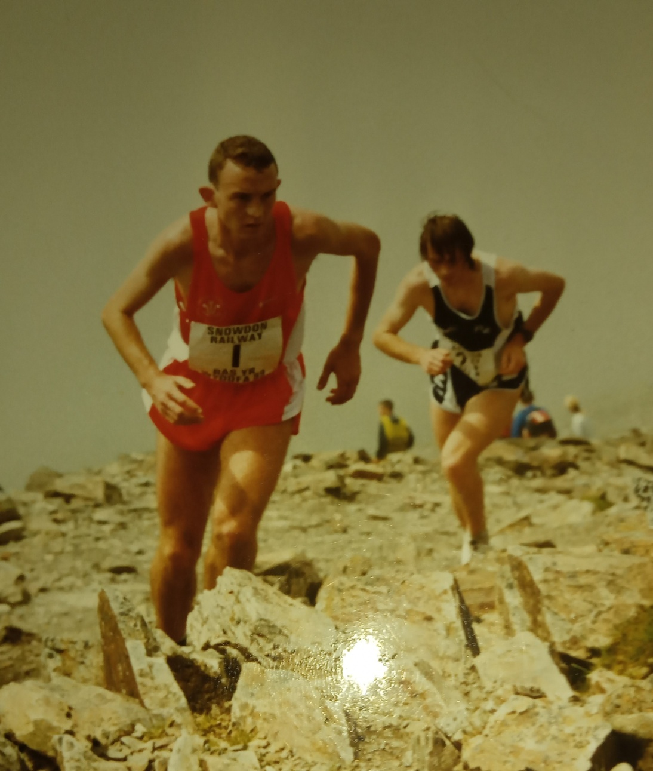

Colin Jones was a prodigious talent winning Welsh titles from an early age and in 1994 he became the first North Walian athlete to win a CAU Inter Counties Cross Country Title. Colin won titles on the road, cross country fells and track.

1: How and when did you start running?
My first race was a Heartbeat Wales fun run. I ran in plimpsoles, there were no prizes as such but I ended up with a t-shirt
and I thought it was the best thing ever. The event was organised by the Bangor lions in November 1985.
I joined Eryri in April 1987, did some Gwynedd xc leagues, and Deeside xc leagues in the early days of my development.
I progressed from 2nd place in the Snowdon Race 1987, then qualified for the Welsh schools xc team for the schools
international in Irvine Scotland in1988.
My first race was a Heartbeat Wales fun run. I ran in plimpsoles, there were no prizes as such but I ended up with a t-shirt
and I thought it was the best thing ever. The event was organised by the Bangor lions in November 1985.
I joined Eryri in April 1987, did some Gwynedd xc leagues, and Deeside xc leagues in the early days of my development.
I progressed from 2nd place in the Snowdon Race 1987, then qualified for the Welsh schools xc team for the schools
international in Irvine Scotland in1988.
My first race was a Heartbeat Wales fun run. I ran in plimpsoles; there were no prizes as such but I ended up with a t-shirt and I thought it was the best thing ever. The event was organised by Bangor Lions in November 1985.

I joined Eryri in April 1987; did some Gwynedd Cross Country Leagues and Deeside Cross Country Leagues in the early days of my development. I progressed from 2nd place in the Snowdon race 1987, then qualified for the Welsh Schools cross country team for the Schools International in Irvine, Scotland in 1988 (Colin finished ??)

2: My records show you first won a North Wales League race as an Under 17 on your homer course at Nantporth. Do you have any recollections of this race?
Not really. My memory isn’t that great. I did prefer the Nantporth course to the Treborth course as it was hillier.

3: My records show that your first senior win in the North Wales Cross Country League was at Bridgnorth on 2nd October 1993. Do you have any recollections of your first senior win?
No, but I did share the senior men league title with Emlyn Roberts in 1992, while also picking up the junior men title and helping Emlyn to win the senior men which was quite memorable.

4: You won at Under 15, 17 and 20 before winning two senior North Wales cross country titles. What memories do you have of North Wales Championships?
The North Wales Championships have always been a good test of progress for the winter training. I have a number of good natured races with some of my team mates at that time. Henry Stansfield at that time was a great Team Manager and able to get the very talented Eryri runners to turn up. Those years were golden in terms of the team mates I had.

The banter with David Alun Williams is something that I will always treasure. He worked hard to organise those events and I don’t think we forget everyone was amateurs and there was no money in the sport.

5: In 1994 you became the first North Wales athlete to win a CAU Inter Counties cross country title when you won the Under 20 title. I remember chasing round the course screaming at you. What do remember of that day?
Well to put the day in context it was the culmination of a two year comeback. I had damaged my knee playing football a few weeks after the World Cross Country in Boston in 1992. So I had picked myself up (with huge support from my family); missed out on the 1993 World Cross Country as a junior, and placed somewhere in the low 100’s in the CAU Inter Counties the previous year.

I knew I had to get a fast start, which I did. After the start I was in the lead and there was a dip and a bit of a hill. Christian Stephenson came flying past me up the hill but once it leveled off I changed gear, went past him and it was a bit of a procession after that. He was broken and fell back to third but he did climb back to finish second.

It was one of those business as usual day; it felt comfortable, hence the 45 second victory.

6: You won Welsh Cross country titles at Under 15, 17 and 20 and finished 3rd in the 1995 senior men’s race. What recollections do you have of Welsh Cross Country Championships?.
The one in Heath Park stands out. It was a sleety freezing day. My poor sister was running in those days and had been dumped in the car to warm up!

I ran the race and my gloved hands were freezing. My Dad guided me back to the car and my poor sister was in the same position we had left her about half an hour earlier There is a picture of me somewhere looking like a drowned rat!!

7: You ran for Great Britain at both cross country and on the mountains. Tell us about your experiences.
The World Cross Country in Boston (March 1992) was one of the best experiences of my running career. From the perspective you have to peak for the trials, where I scrapped in, and then peak again at what is the end of the cross country season. Once you are in the team you have to maintain and taper the training, and then try not to be distracted. Being in America with the likes of Paula Radcliffe and Liz McColgan, and Eamonn Martin was fantastic. Bud Baldaro was the Team Manager and kept the atmosphere fun and friendly.

I was determined to justify my position, and fortunately I ended up as the third scorer (5 seconds behind the first British Junior) over the line which was great (being a year younger than the whole of the team). I think the snowy, wintery conditions suited me perfectly and I set off sensibly, aiming to at least be a team counter. (Colin finished 31st in a race that Haile Gebrselassie finished 2nd to Ismail Kirui of Kenya and the Great Britain team finished 6th). The ladies races couldn’t have been a bigger contrast of fortunes what with favourite Liz racing poorly and Paula becoming junior champion.

The Portugal GB cross country invitation (6 February 1991) came on the back of a Durham County invitational (29 December 1990). I qualified, if that’s the word, by running away from Gebrsesassie’s brother in the Under 17 race. The guy on the tannoy had no idea who I was. I think the poor Ethiopian was expecting an easy run. The course had an uphill section, then flat, and a steep decent and by the time I got to the bottom 0f the steep decent my opponent was rather crestfallen.

In the race in Portugal I placed 10th out of 40 which was pretty good as it was an Under 20 event. It was one of those three day trips where you fly in, go to the course, do the race and back home.

The fell Great Britain International was in Italy (18-19 August 1990). It was a limited international with Italy, Austria, France, Germany and USA competing. I was in the junior race with Gavin Bland. The senior team consisted of Colin Donnelly, Paul Dugdale, Paul Wheeler and I think Basher Husain who were paired in a two man relay. It was a great experience I came 16th out of 32.

The race started in a small dusty coliseum; my lungs were full of dust by the time I got to the first water station. The trip to the airport before was eventful; to save money I travelled down through the night with Colin Donnelly falling asleep at the wheel, after he had completed a 12 hour shift at Ysbyty Gwynedd.

The 1995 European Cross Country Championships in Alnwick, I made the senior men’s team in my first year. With hindsight I was what I call great shape but I was stale, and flat. I ran sub 50 (48:50) at Llandudno (the infamous short course!!) to qualify. Alnwick was a strange race and we were jogging the first few kilometers. I took the lead for a bit to try and get the race started. (1995 was the second European Cross Country Championships with the first also having been held in Alnwick the year before - Colin finished 55th and the Great Britain team 3rd)
8: Which performances during your career gave you the most pleasure?
I was always happy performing well at international events, but there was a lot of responsibility to live up to the expectations.

It was fun and completely unexpected winning the Snowdon race. I wasn’t trying to; in that I had come home from America for the summer and was training with Alun Vaughan to get him fit for the World Mountain Championships. I was a last minute pick for the Welsh team and the stars aligned for me on that day. (Colin won the Snowdon Race in 1998 in 65:14)

I was also a member of the Welsh Team of Craig Shepard, Tim Davies and Ian Pierce that won Bronze Medals in the World Junior Mountain Championships in 1993 in Gap, Hautes-Alpes, France.(Colin finished 5th overall and first British runner home).

9: And most disappointing?
There haven’t been any disappointing performances. My biggest disappointment was injuring myself playing 5-a-side football after Boston, but the cross country season was over and I was in limbo period of training very little after a very successful cross country season. I should have just gone out drinking instead (in my mind there’s a second World Cross vest, and a whole junior year that I missed out on). Of course there is no guarantee of getting back to back years on top, even if I hadn’t got injured.

10: What was a typical week's training at your peak?
For cross country:
Monday – Track session 8-16 x 400/300 increasing reps, decreasing recovery to 60 seconds/100m jog recovery.
Tuesday – Llanberis Hill session (decreasing recovery)
Wednesday – light weights and flexibility (strength)
Thursday – some form of grass based Fartlek
Friday – Always Day off
Saturday – usually a race depending on the level of fitness
Sunday – long steady run/day off depending on fatigue levels/race

MPW 25-40

11: You went to study in America and after that we didn’t see too much of you. What happened and what was America like?
Well I wasn’t particularly academic but the plan was to get a basic science degree and work in Llanberis for an American company and continue the running. There were a lot of runners working there then, and it was a small business (hour for lunch, finish early on a Friday sort of thing). So I did two years in Kansas (scholarship), coming back to Llanberis in the summer to make a few quid.

When I won the Snowdon race I had improved my track times running with Kenyans and still a couple of British (Ian Oliver, Colwyn Bay and Danny McCormack) runners.

To complete my studies I went to a small Catholic University with an indoor track and got my 5km/10km pb’s down to 14:15 and 30:03. After graduation I had got my foot in the door of a speciality chemical manufacturer and with a temporary work visa I progressed quickly within the company and got them involved in the Corporate Challenge.

I kept in touch with the son of one of the coaches and we got a group together to do the Dino Trail Race Series. I completed the Las Vegas Half Marathon in 1 hour 16minutes. The road racing circuit only sponsors USA athletes .

The American experience was valuable. I was somewhat lucky with the coaches they left me to my own devices, with my training and I produced the results so there were no horror story there about 200 mile weeks and burning out.

When I returned to the UK in 2004, everybody had moved on both work and running wise, which is fair enough.

12: You were a reluctant track and road runner preferring the country or the hills. Was this just because of where you lived?
The athletics track in Treborth wasn’t opened until 1996, so it was Colwyn Bay once a week until then, and by that time I was off to America at the age of 24. I was also injured for a year following Boston in 1992/93.

I wasn’t reluctant on the road and I have done several sub 30 minute 10kms. I was third in the Welsh 10km Championships in Llanrwst in 1991, which also doubled up as a road international. I was just 17 at the time and recorded 31:01. In 1994 I also finished 13th in the Swansea Bay 10km in 30:17. I have a bronze medal from the AAA 10km (aged 21) Championships in Redditch in 1995 (won by Paul Taylor, Copeland in 29:20). I also did 30:09 for the Menai Mini Marathon on my own on a long course.

On the track I have until recently held the Welsh Schools 3000m record (for which I added the schools track outstanding performance award to the cross country one).

For example the year I won the CAU Inter Counties Cross Country, I was fourth in the Welsh 5km championships in 14:58. I ran an 8:29 3,000m in the Welsh Games at Wrexham in the same year. Also I was first Welshman at Llanrwst in 30:27 (12th overall). I finished 1994 with the aforementioned Swansea Bay 10km.

In the summer of 1995, I ran 8:24 for Wales in the Inter Region Match at Alexander Stadium, Birmingham and ran 29:46 in the Great Welsh Cardiff 10km the following week. Two weeks later I was in Peoria with Bud Baldaro in the Steam Boat Classic in the USA – 4 miles in 18:46. The following week wearing a Welsh vest again I ran 8:07 in the 3,000m in the Cork City Games. Two weeks later I ran 29:48 Milton 10km, having fitted in the Aberdaron 8 miles and the Felin Heli 10km (those last two races treated as training).

Two days after the Milton 10km I finished fourth in the 3,000m (8:29) at Cwmbran running for Wales in another Inter Region Match. Redditch (29:41) was two weeks after Milton. I finished off the year with Atlanta 10km Classic with Sir Roger Bannister and Sarah Bentley and a Welsh vest in Arthur Seat, Edinburg, Scotland (which could be argued more of a cross country course given the number of laps that Englishman Martin Jones won that year.

My Dad and I had established that you can’t maintain your peak the whole year round. We kept the quality and intensity high, the mileage low, focusing on injury prevention and the cross country season. The hills on a Tuesday evening during the summer kept the whole thing fun. It’s like the cross country it has great banter and it keeps your feet on the ground. The hill running also provided for international Welsh vests running in Europe which were relatively easy to obtain running for Eryri Harriers.

I can count on one hand the number of Welsh vests that I have turned down, and that was usually because I had obligations in America. There is that double edged sword of trying not to turn down opportunity while trying to maintain the level of performance. Also you are often not taken seriously on the track or road if you set foot on the fells, so I tried to keep my options open!

(Colin has well and truly proved he was much more than a cross country and fell runner and his road and track performances indicated above show he was a man for all surfaces)

13: Tell us your pb’s:
3,000m - 8:07 Cork City Games
3,000m indoors - 8:12 Cosford
5,000m indoors - 14:15 Butler Invitational
10km - 29:41 Redditch 10km
10 mile - 48:52 Llandudno (*short course)

14: What are you doing these days to keep fit?
Mountain biking a bit
15: Comments on:
(a) Running in North Wales
It’s a great place to run

(b) Eryri Harriers
They were very supportive in my heady days. Their focus at that time was mountain running. They helped a lot when I hurt my knee and the phone stopped calling.

16: Any other comments?
Yea, a lot of people put a lot of effort into supporting me. I clearly had some talent, but my weights coach Dave Jones’s daughter is in the Commonwealth team, gave up two hours every Wednesday throughout the winter to focus on me. My Dad drove 70 mile round trip to do track training in Colwyn Bay and Alun Vaughan was an instrumental team mate on those sessions. Not to mention my poor mother who put in a lot of time and support.

Once again a fantastic Spotlight by one of North Wales’ most talented ever runners. A great insight into an athlete who achieved a great deal.

