LYNNE WRIGHT (nee MADDISON), COLWYN BAY, SALE, WREXHAM & PRESTATYN

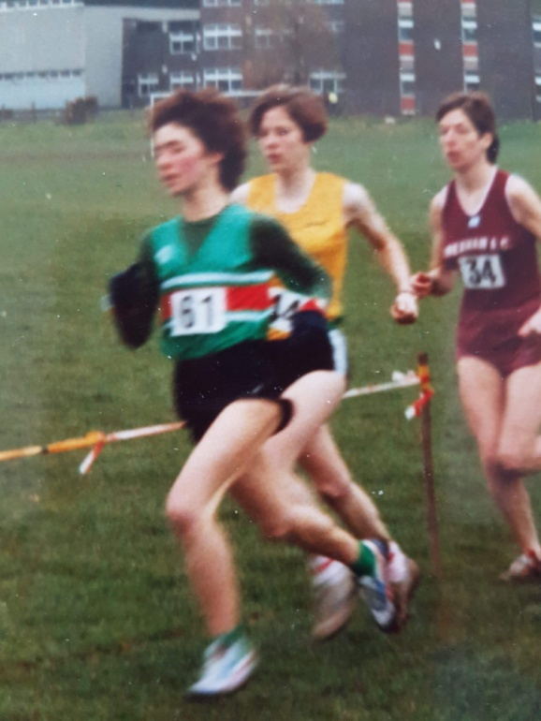
Lynne Maddison
North Wales Cross Country Championships, Kelsterton College

Lynne Wright (nee Maddison), started running at an early age and quickly became the top female runner in North Wales. She won a record 7 senior women titles starting with a double in 1986 and 1987, another title in 1990 and then four in a row from 1992 to 1995. Lynne finished 2nd in the Welsh Champs 1500m in 1986 and 3rd in 3000m in 1984 (at just 16 years old) and third on three occasions in the Welsh Cross Country Championships.

1: How and when did you start running?
I started running in 1982 when I moved to North Wales from Manchester age 14 years. Initially I was a sprinter but soon realised I could run longer distances.

2: My records show that with seven wins you are the most prolific female winner in the North Wales Cross Country Championship with your first win in 1986. What memories do you have of any of your North Wales Championships wins and which was your favourite.
I have great memories from all my North Wales Cross Country Championship wins. Competing in this race was always important to me – it was running on your home ground, meeting up with all your fellow athletes and you were certain to represent North Wales in the British Inter Counties Cross Country Champs if you won.

Probably 1986 was my favourite win because it was my first and it was on a brilliant course at Denbigh with a couple of testing hills.

3: You finished Bronze medalist in the Welsh Cross Country Championships (1986, 1991, & 1995). What recollections do you have of these runs?
I can remember them well. However my favourite performance was in 1986 at Cardiff as I gained selection for my second World Cross in Switzerland and ran a close third to Angela and Susan Tooby (Angela and Susan Tooby finished equal first in 17-58 with Lynne 3rd in 18-36).

4: You competed for Wales in the World Cross Country Championships on three occasions with a best finish of 60th in Poland. What do you remember of these races and running for Wales?
I remember each of these races. The first one in Lisbon, Portugal in 1985 was a massive occasion for me. I was 17 years old and it was my first trip abroad representing Wales in a major international – it was a real baptism of fire and the race itself was a blur.

The following year in Neuchatel, Switzerland was very similar.

However in Poland 1987 I really felt involved in the actual race and managed to stick to my race plan of trying to move through the field as best I could. I was second counter for the Welsh Senior Women’s team in the end (just 9 seconds behind Susan Tooby who was first scorer in 45th place).

(Lynne finished 108th in Lisbon; 129th in Neuchatel – won by Zola Budd; and 60th in Warszawa – Liz McColgan 2nd for Scotland)

5: You were very much a cross country and road runner so what were your pb’s?
P.B’s on the track:
800m - 2.13;
1500m – 4.26;
3000m – 9.28;
5000m – 17.19.7.

P.B’s on the road:
5km – 16.52;
5km – 16.09;
5m – 28.09;
10km – 34.02;
10m – 57.53;
Half Marathon – 78.21

6: You had great success particularly in the mid 1980’s but what performances gave you the greatest satisfaction?
I think I would have to say the 1986 Wrexham Town Centre Road Races 5km where I was only one second behind Olympic athlete Christine Benning in 16.09.

1986 Rhyl Kodak Classic 10k (incorporating Welsh 10k Champs) which I won in my P.B of 34.02 and also took the Welsh 10k title(Lynne won the title by nearly 3 minutes from Pat Gallagher, Westbury. Lynne also won the 10km title again in 1994 beating Nicola Haines Jones, Newport, and Bronwen Cardy-Wise B&R.

7: And the greatest Disappointment?
Don’t really have one!

8: What was a typical week's training at your peak?
I was training fairly hard at my peak and often did two sessions on some days - easy am run and then a track session at night.

Track work was long reps and shorter faster reps in a group to pull each other round.

Also I did quite a high mileage and always a long run on Sunday if not racing often over the country in winter and on the road in summer.

9: You made a couple of comebacks and had some success. Why did you initially stop and what do you remember of your comebacks?
I have never actually stopped running. I just think that sometimes you don’t always feel like racing (especially when it has been your main focus for years).

Comebacks are great because you are very motivated and are hungry to win.

10: You competed for four clubs during your career – Colwyn Bay, Sale Harriers, Wrexham AC and Prestatyn RC. Tell us about your experiences with each.
Colwyn Bay was my first club and I was a member for the longest time of any I have competed for. I have fond memories from my time there and also from Wrexham AC and Prestatyn RC too!

Sale Harriers was a large club and I didn’t really get to know many people that well.

11: Tell us what you are doing these days.
I am still doing plenty of running and I also cycle, swim and enjoy walking.

Our young son is a good swimmer and cyclist and we give him lots of encouragement.

12: Comments on running in North Wales
Running in North Wales is great. We are very lucky to have such beautiful places to run and some brilliant races and courses.

The running scene seems pretty healthy at the moment and you definitely see more people out running nowadays.
I was very saddened to hear that David Alun Williams is no longer with us. He was so passionate about North Wales Cross Country and put 110% effort into all the organization- it was a big part of his life. He never missed a North Wales XC League race or North Wales XC Champs often taking part in the Senior Men’s race himself. He loved taking the North Wales team to the Inter Counties and supporting us all in his own way with lots of friendly banter on the bus to help with the race nerves!

During the 1980’s Lynne was the outstanding female talent to come out of North Wales running anything from 800m to half marathon and had success at all of them, but first and foremost Lynne was a traditional harrier.

