SPOTLIGHT WITH IAN PIERCE

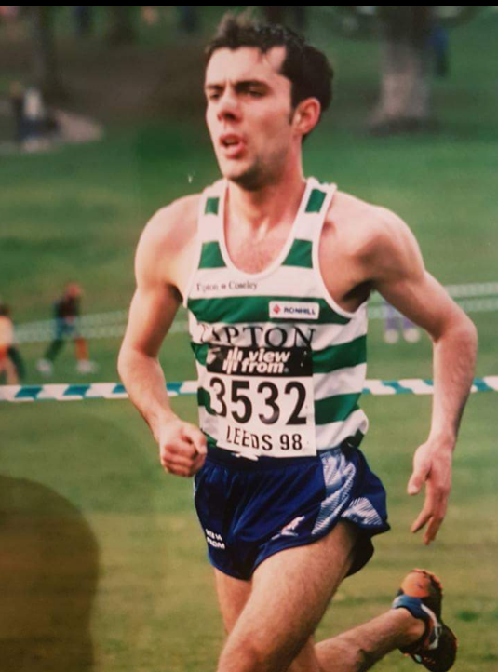

1: How and when did you start running?
I played football from a very young age and one night I went to the Racecourse to watch Wales v Spain (famous match) and Dad said lets run home and I didn’t stop all the way home (Ian lived between 2-3miles away from the racecourse). It went from there and I joined Wrexham AC.

2: My records show you won North Wales Cross Country Championship titles from Under 13 right through to your two senior men titles. What recollections do you have of any of your wins?
I always enjoyed North Wales Championships and they meant a lot to me and my Dad. I don’t remember any of the ones when I was younger but I do remember the Denbigh course which was hilly and tough and suited me.

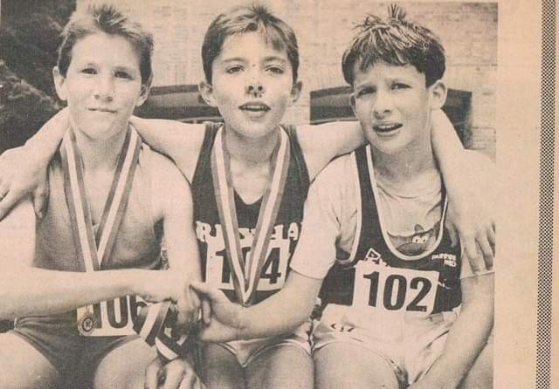
One of Ian’s early victories. Ian in centre with Rob Pierce also of Wrexham on right
Ian won the following North Wales titles:
1989 - Under 13 title
1991 - Under 15 title
1993 - Under 17 title
1995 - Under 20 title
1997/2001 - Senior Title

3: You won your two senior North Wales Cross Country titles (1997 and 2001) sandwiched between wins by Eryri’s two Colin’s – Colin Jones and Colin Donnelley – both formidable competitors. What recollections of your two wins do you have and competing against the two Colin’s?
(Ian’s memory is going as he thought he won his first senior at Denbigh but it was at St. Asaph). Colin Donnelly was running really well but I lead him gun to tape. I respected Colin Donnelly but also believed in myself.

Colin Jones was like a big brother to me and always encouraged me and looked out for me. I always told him I would beat him and I did.

4: You joined Tipton Harriers at a very young age. Can you explain the rationale and the benefits you gained
I joined Tipton to step to the next level and train with some top runners and under the guidance of Bud Baldaro. Bud’s group was stacked with some of the top runners including Dave Payne, Kevin Lamb and others. The group helped me train harder and faster. I also trained with Henrik Ramalla, South Africa.

(Ian also had some great run’s with some of the World’s leading distance runners including Commonwealth Games medalist Steve Moneghetti and Lee Troop in the snow and blizzard in the Scottish Highlands the day after a hard 5 mile race. Despite their reputation and class, Ian never gave an inch!!).

5: Right from an early age you competed in Welsh Championships finishing 3rd at under 13, 2nd at under 15 before winning at under 17 in 1993. You had some great battles over the years with athletes like Justin Thomas and Andreas Jones. Tell us about your battles to win Welsh titles
I never liked either of them but they were good athletes. I always felt that it was me against the rest of Wales and Welsh Athletics made things difficult for North Wales athletes.

I got to the Welsh Inter Counties Under 17’s race just 15 minutes before the start as the bus had problems after leaving Wrexham at 6-00am in the morning. I put my spikes on as Dad ran for my number. I won but as I crossed the line Mark Finlayson’s coach said “Another half mile and Mark would have beat you” – I smiled, LOL!!

Next was the Welsh Championships and I won by even further with the course being an extra half mile. I said to Mark’s coach the extra distance was Great! LOL!! Like I say, it was always me against the rest!!

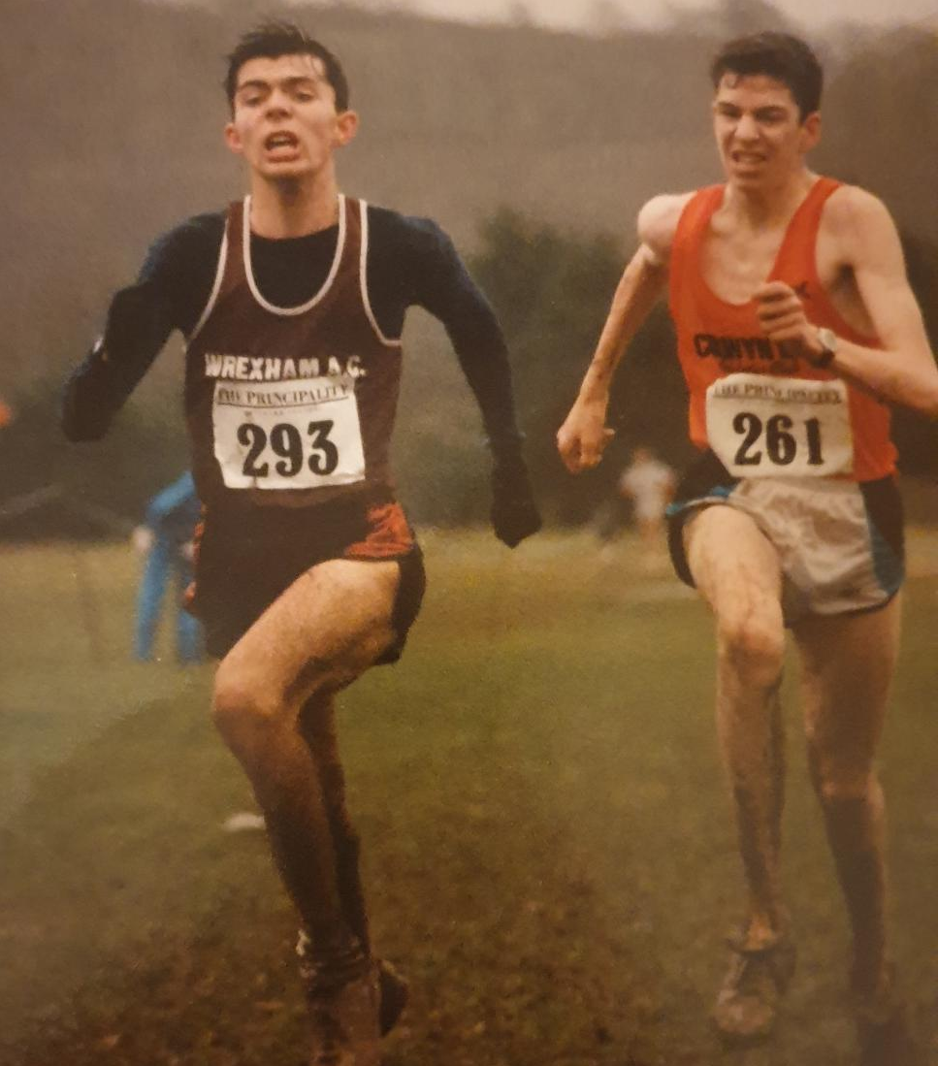
Ian driving his way to another victory
6: You became the only North Walian in 122 years to ever win the Welsh Senior cross country title at Eirias Park in 1999. What recollections do you have of the race?
This is my proudest moment! I had been ill before it but felt strong and in good shape. Andres Jones had said on BBC Wales before the race that he was going to win. The race started and broke away. Andres pushed on but I knew the course and had beaten him on it before, so I waited and pushed uphill and through a muddy section. I was stronger than I looked and one of the Tobin brothers from Swansea was shouting me on; my parents and friends were screaming once I was in front. I was confident and pushed hard crossing the line to win.

Winning the Welsh title meant everything. That is the first time I ever saw my Dad cry. Winning that day was for everyone in North Wales, Wrexham and Tipton and everyone who had helped and believed in me.
(Ian won the Welsh title by 27 seconds from Andres Jones in second and Colin Jones third).

7: What were your pb’s?
5mile - 23-22
10km - 29-05
Half Marathon - 63-58

8: You had some terrific results both as an individual and as a Team competing for Tipton Harriers. Which were the most pleasing?
My first senior English National cross country gold medal in Havant in1997 when I finished 47th as a first year senior over 9 miles. I’d missed 3 weeks training before it but Tipton was like a family back then thanks to Bryan Clifton and Bud Baldaro. (Tipton won the Gold medals with Ian being 6th scorer in 47th place. Bingley were second and Coventry third).

Also finishing first scorer over 9 miles at the English National cross country in Roundhay Park Leeds in 1998 my second English National (Ian finished 18th and Tipton picked up silver medals behind Bingley with Morpeth third). which was the last one over 9 miles.

Then every 12 stage and 6 stage were special days (Ian and Tipton regularly won medals at both the National 12 stage and 6 stage relays at Sutton Park).

Individually I always loved a battle but can’t remember everything but I do have some records of winning the Welsh senior cross country title, captaining Wales and also running for Great Britain.

A day that will last long in the memory is the Alsager 5 mile on 7th February 1999. Always a top quality field and this was no different. There was a group of us at the front – Dave Tune, Rob Birchall, John Nuttal and me and I remember my dad trying to keep up with us on his bike!! With a mile to go I remember thinking I want top 3 here and thinking who’s going to drop and praying it wasn’t going to be me! We all kicked close to the finish with Dave Tune winning in 23-30, Rob Birchall 2nd in 23-33, me third in 23-35 and John Nuttal fourth in 23-37. As I caught my breath and was thinking “Wow, I’ve just beaten John Nuttall”, my Dad came round the corner on his bike and his first words were sorry I couldn’t keep up with you. Happy memories.

9: And most disappointing?
Being top 5 junior all year and not being picked for the World Cross Country Championships despite providing a Doctor’s note saying I was not to run the Trial race. I still believe that it was I was Welsh that the selectors said I wouldn’t be pre-selected so I was forced to run and ended up in an ambulance. I wanted that so badly. They took a runner who hadn’t previously finished within 2 minutes of me! Not bitter!! LOL

10: What was a typical week's training at your peak?
A typical week’s training was around 90-95 miles:
Sunday - Long Run 15 – 18 miles
Monday - 2 runs
Tuesday - Session in Birmingham in evening - 3m warm up/20 x 400metres (jog rec)/3m c/down
Wednesday - 1 run
Thursday - Tempo or Fartlek
Friday - 2 runs
Saturday - Session during day + evening run

11: You retired relatively early from running and played semi-pro football. Can you tell us why the change?
I felt I needed to go full-time to go to the next level but I couldn’t afford to. My Dad wanted to continue working to support me rather than retiring! I felt this wasn’t right, so I decided to stop. Working full-time (Ian was a Council electrician at the time so was physically on the go all the time) and the high mileage I felt I needed the extra time to recover and I couldn’t do that if I didn’t go full-time.

Yes, I went back to playing football semi-professional and my fitness played a big part in the football. The money I made playing football paid the mortgage. I loved football but loved running more and feel there needs to be more help in running.

12: It’s over 20 years since you won that Welsh title and you’re now a master!! Is there likely to be a comeback?
Yes its 20 years now and now a Master I’m back running and building up very slowly. I have motivation from someone special and just need to get my hamstring sorted and see what shape I am in before I race

13: Comments on: (a) running in North Wales
(b) running for Tipton Harriers

I loved all my time in North Wales and Tipton and feel part Welsh and part Black Country! I have made some amazing friends in the sport.

I was also fortunate to have some great coaches and Team Managers who helped me along the way. At Wrexham my first coach was Les Baldwin and Team Manager and Chairman was David Alun Williams who along with Ron Jones did great things for distance running in Wrexham and North Wales. Sadly all three are no longer with us but set me up on my running career.

Equally I am grateful for the support and guidance I received when I moved to Tipton at a very young age and in particular from my coach Bud Baldaro, one of the sport’s true legends, and Team Manager Bryan Clifton along with Tipton stalwarts, Stan Jones and John Satchwell.

Both clubs were ‘family’ clubs and looked after their athletes, particularly the younger ones and I am grateful to have had the opportunity they provided.

14: Any other comments?
I was lucky to experience lots of fun and laughs and meet great people

I won many races and titles of which I will always be very proud. I loved racing and enjoying the craic with the lads. As an example on 19th September 1999 I won the Lake Vyrnwy Half Marathon and seven days later I was competing over the same distance again finishing second in the English Half Marathon Championships in Nottingham (66-30) and helping Tipton to team gold medals as well.

Running was always a release for me and I’m trying to get back. Thanks everyone who supported and helped me along the way.

Winning the Welsh Cross Country Championships should have been the start of Ian’s international career but sadly earning a living as a full-time Council electrician and therefore unable to commit to the level of training and recovery required to reach the next level, Ian was lost to the sport. However, in his short career Ian won many National medals with Tipton along with his many Welsh titles.

He still remains the only North Walian to have won the Welsh Senior Cross Country title so will always have pride of place in the history of North Walian athletes.

