SPOTLIGHT WITH GEORGE NIXON, PRESTATYN RC
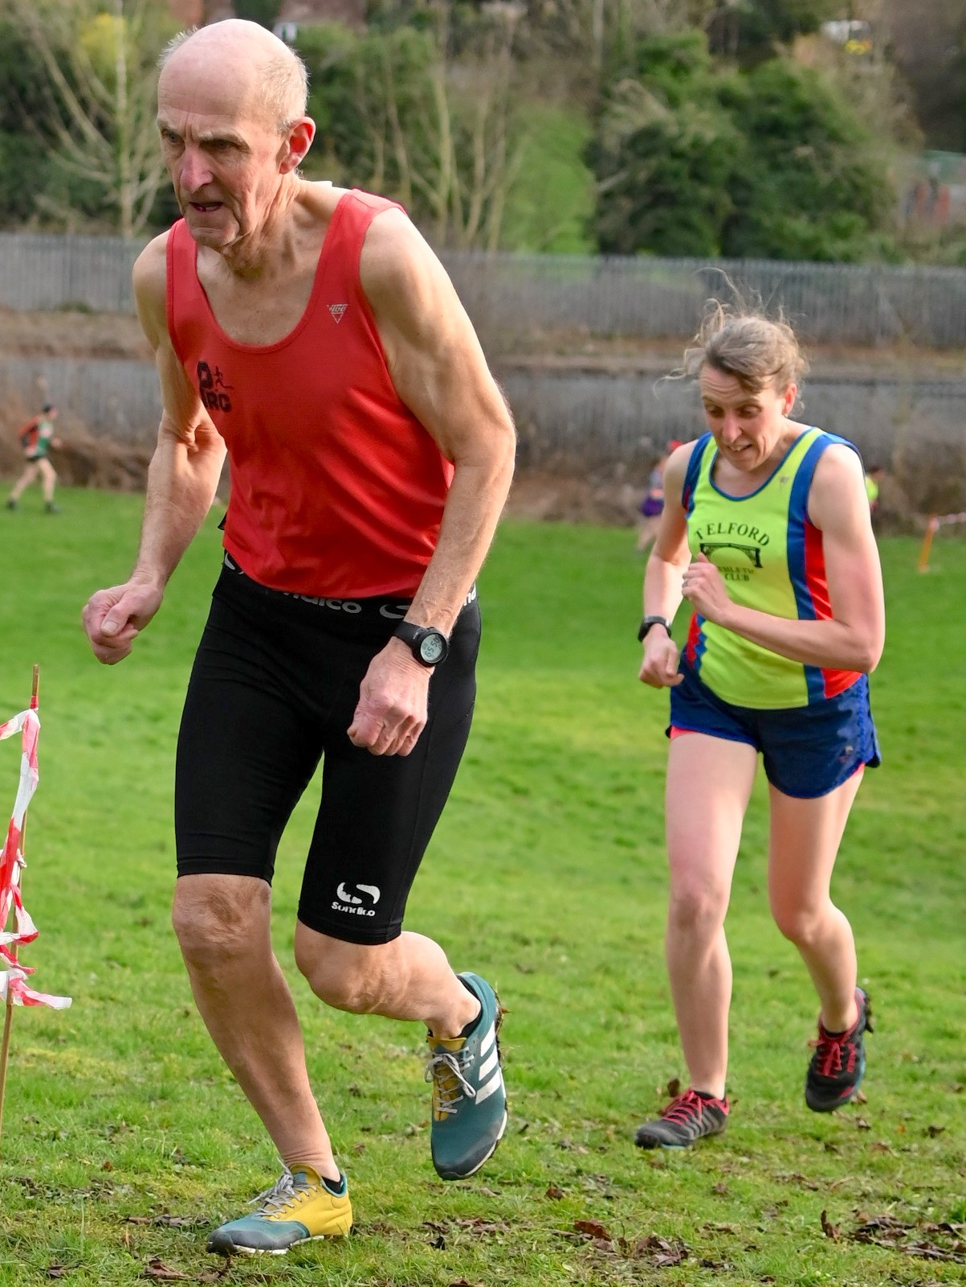

George Nixon has been competing in the North Wales League as long as I can remember (he was a member of Wrexham when I joined in 1974 and somebody I looked up to) and by my calculation he has probably ran more North Wales Cross Country League races than any other athlete.

1: How and when did you start running?
I started running in 1974 and was a fun-runner to start but was asked by Dave Hughes, who then lived 100 yards away from me, to join the rest of Wrexham members from the Rhyl area.

2: Initially you were a member of Wrexham AC. How come? And when/why did you move to Prestatyn RC?
Wrexham was the main North Wales club at the time and a lot of their good road runners were based in Rhyl. I joined Prestatyn in 1990 because it was a convenient, local club, and a few of the former Wrexham lads had already moved to Prestatyn.

3: You won the North Wales Cross Country Championship in 1983, sandwiched between three of Tony Blackwell’s wins. What do you remember of that race/those years?
I’d been runner-up 2 or 3 times and Tony Blackwell didn’t run the year I won, but what really pleased me was that I beat Tecwyn “Taff” Davies, Aldershot and Farnham and District (and Army), who was also from St. Asaph, and who was the World Masters Champion. I think it was my best ever run!

4: You won the North Wales 10 mile championships a record number of times. Was that your favourite distance and what do you remember of those races?
Cross country has always been my favourite discipline but I’m proud of my record of winning the North Wales 10 mile Championship seven times in total, and six times in succession. My winning times between 1977 and 1984 were: 51-32; 52-57; 51-59; 51-54; 51-57; and 52-08; which was pretty consistent.

Having said that, my favourite road racing distance is probably 5 miles.

5: You have been competing in the league for nearly 50 years and by my reckoning you have run more North Wales Cross Country League races than any other athlete. You’ve seen many athletes and many top performances over the years. Tell us your favourites.
There have been some really good quality runners in North Wales over the years but Tony Blackwell (Wrexham) is probably the best of the lot. He was in a class of his own for so long. Others who stand out are Colin Donnelly (Eryri Harriers), who was such a tough competitor and Chris Davies (Telford). Even if you happened to be ahead of Colin towards the end of a race you’d know that he would come storming past.

6: You competed for Wales both as a senior and master but what performances have given you the greatest satisfaction?
My only Welsh representation as a senior was against the RAF and Army, which were not classed as internationals, but I’ve run a few times in the Masters Cross Country International. Ironically one of my most pleasing performances came when I was amongst the reserves for the Masters International in Cardiff. I ran in the reserve race, which I won, and my time was quicker than some of those in the full team.
7: And the greatest Disappointment?
The disappointment which has stayed with me is failing to break 2-25 in the 1983 London Marathon. I did 2-25-09 and at least had the satisfaction of just beating the first lady, Greta Waitz!!

8: What was a typical week's training at your peak?
Sunday: - 20 miles;
Monday: - 10 miles;
Tuesday: - Normally a 2 hour run;
Wednesday: - About 10 miles with the lads in Rhyl, which was very competitive!!
Thursday: - 6 miles plus 15 x 200m (100m jog);
Friday: - Rest
Saturday: - Race or 10 miles

9: How have you changed your training as you got older and how do you keep your enthusiasm for the sport?
I’m 68 now, and it’s more a case of just ticking over. I do a total of about 25 miles a week, the longest run being about 7 miles.

10: What were your pb’s?
5km: - 15-20
5miles: - 24-16
10km: - 31-20
10miles: - 50-35
Half Marathon - 69-45
15miles: - 79-11
20miles: - 1-47
Marathon: - 2-25-09

11: Comments on:
- Running in North Wales
It’s good to see so many more runners in the North Wales Cross Country League and other events nowdays. When I started there were hardly any women, for instance, but I think there was possibly more strength in depth in those early days. We also used to travel to big races in places such as Sale where one used to come up against top internationals.

- Wrexham Athletic Club
It was great being part of the club’s success in the 1970’s and 80’s. I owed a lot to Les Baldwin who always kept in touch, urged everyone to turn out in races and arranged lifts. I’m glad that the club is enjoying a bit of a revival at the moment.

- Prestatyn Running Club
There are a lot of good runners in the club but I would like to see more of the men turning out regularly in the Cross Country League as they do in the Border League. The ladies and super vets have proved that there are medals to be won in many of the major championships.

12: Any other comments:
I have gained so much enjoyment from the sport over the years and there have been many highlights. I ran for North Wales several times in the CAU Inter-Counties Cross Country Championships, which I regard as the “FA Cup Final” of the sport, with many of the country’s top runners taking part. My best result was 44th – if you come in the top 100 you’ve done very well – and I remember hearing David Alun Williams and Les Baldwin shouting at me.

I also used to enjoy the North Staffs Cross Country League, and a year after winning a gold medal for the best newcomer in 1977 I came second overall

At the end of the 2019-20 Season, George was presented with the Arthur Bebbington Trophy for his services to the North Wales Cross Country League. George is one of life’s gentlemen but this hides a fierce competitor.

